Multimedia describes any application that uses multiple media (graphics, text, animations, audio, and video).
Multimedia is primarily thought of as any application that uses high-bandwidth media (audio and video) and is most often delivered on CD-ROM.
Multimedia does not describe the purpose of the application, such as game or a presentation.
Multimedia also describes electronic media devices used to store and experience multimedia content. Multimedia is similar to traditional mixed media in fine art, but with a broader scope.
The term “rich media” is synonymous for interactive multimedia.
Multimedia comprises of two words “multi” and “media” meaning “many” and “material” through which information may be transmitted.
Multimedia is the dissemination of computer-controlled information in more than one form that includes the use of text, audio, graphics, animated graphics, video, and motion pictures where every type of information can be represented, stored, transmitted and processed digitally.
It presents information in a more structured, presentable and understandable manner.
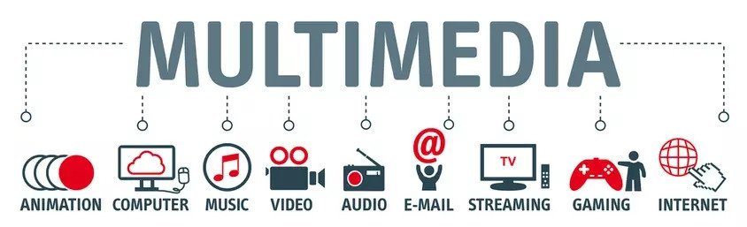

Multimedia System
- Multimedia systems are those computer platforms and software tools that support the interactive uses of text, graphics, animation, audio or motion pictures.
- It is the computer able to handle multiple media, store, digitize, compress, retrieve and decompress the information.
- It includes hardware like CD-ROM, Sound Card such as Sound Blaster or Master Blaster, Microphone, Head Phones, Digital Camera, Speakers, Home Theaters and Multimedia Projectors.
Multimedia Technology
- It is the special computerized technique which helps user by providing methods to combine text, images, and sound or motion pictures.
- It facilitates the user to create, store, edit, delete and copy data.
- Standard file formats are used to create or store multimedia information
- Graphics are stored in .bmp, .jpg, .gif, .tif, .pif, .png formats
- Audio is stored in .wav, .mp3, .wma formats
- Videos and motions pictures are stored in .mpg, .avi, .3gp formats
Software Used In Multimedia
Multimedia is widely used in web, offices, educational presentations, game or business presentation, entertainment, trainings. Hence, programmers or software developers use a variety of software as per the requirement.
- Java (Programming Language)
- Real Audio Or Shock wave (Utilities)
- Active –X of Open Dock
- Windows Media Player
- Flash, Photoshop, Pagemaker, Dreamweaver, 3D-Max, Maya (Graphics, Designing, Editing)
Hardware Used In Multimedia
- High quality display monitors (at least VGA)
- Input device such as mouse, keyboard and scanner
- Voice display facility – sound card, external speakers and a microphone
- Image compression and decompression facility
- Video capture card, mass storage device like CD-ROMs or USB (Universal Serial Bus)
- At least 486 processor with inbuilt math co-processor
Multimedia Application
- The capability of multimedia technology to handle different type of media makes them suitable for wide range of applications and users.
- It has gained world wide acceptance in almost a business, presentation or simulation education or training entertainment, video, graphics, or animations. Some of the areas where multimedia could have direct impact are
  - Video Games
  - Multimedia Presentation
  - Special Effects in Film
  - Public Accessing/Touch Screen Monitors
  - Animated Advertisement
  - Foreign Language Learning
  - Virtual Reality
  - Edutainment
  - Software Training
  - Internet And Interactive Web Pages
  - Office Work
  - Multimedia Server and databases
Virtual Reality
- It is an artificial environment created with computer hardware and software and presented to the user in such a way that it appears real.
- It uses headsets and data gloves.
- It enhances multimedia by supporting real time, interactive three dimensional graphics
Advantages of Multimedia
- It makes teaching learning easier in the classroom
- It makes sharing of views, ideas and thoughts among various people around the world easy.
- It can store the data and information for long time.
- It is very cheap to get the knowledge about the related subject matter in a short time through multimedia.
- It is very easy to use, handle, carry, copy and store data.
- It allows adding audio, video, text and graphics to make the subject matter interactive and attractive.
- It has a wide use in interactive web pages, video conferencing, distance education and seminars.

